
Volunteer Role Description
Gatehouse Volunteer

What is a Gatehouse Volunteer?
Gatehouse volunteers help to collect entrance money on Sundays and events. You are the first port of call for visitors.

What’s in it for you? 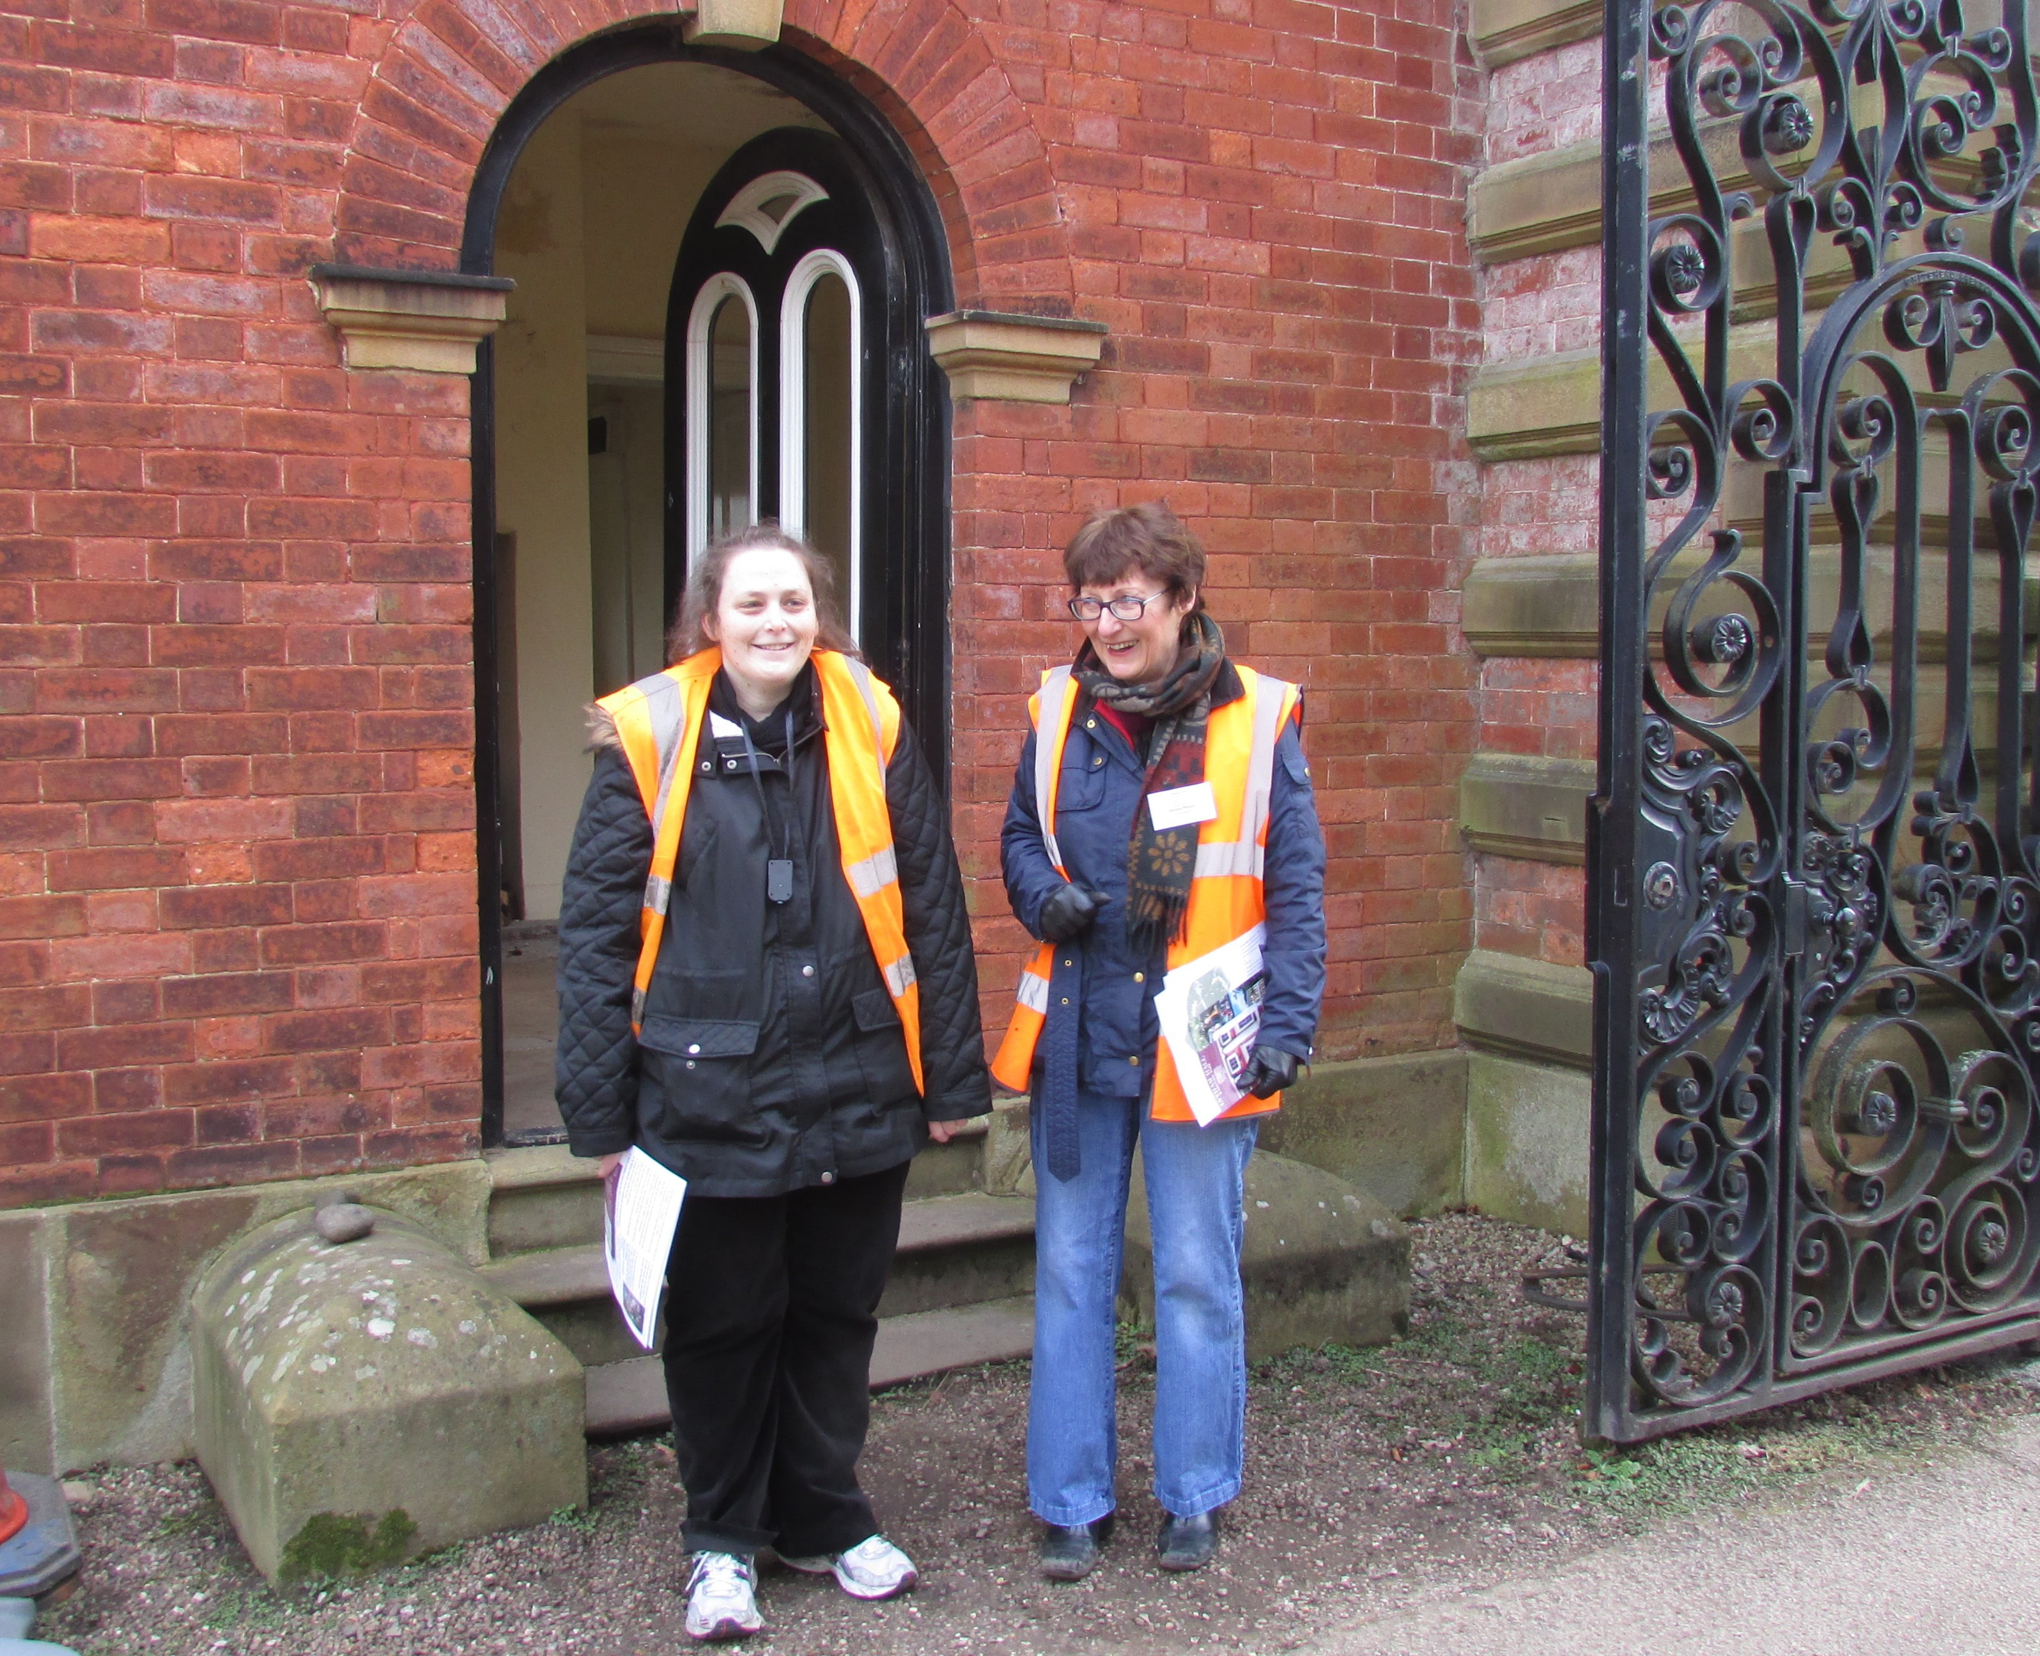
- Become part of a friendly and dedicated team
- Welcome and meet people
- Fresh air and exercise
- Have fun!

What’s involved?
- Welcome visitors on Sundays all year round and at events
- Collect entrance money
- Put out correct signage
- Count visitor numbers
- Give out leaflets, information and answer questions
- Be an ambassador for Lytham Hall

Assisting in providing information to visitors and mentoring new volunteers

Undertaking such other appropriate assistance, as may be reasonably requested by the Lytham Hall team.

Working in compliance with the Trust’s Health and Safety Policy at all times.

This role will suit people who… are outgoing, enjoy meeting and greeting the public and working as part of a team.

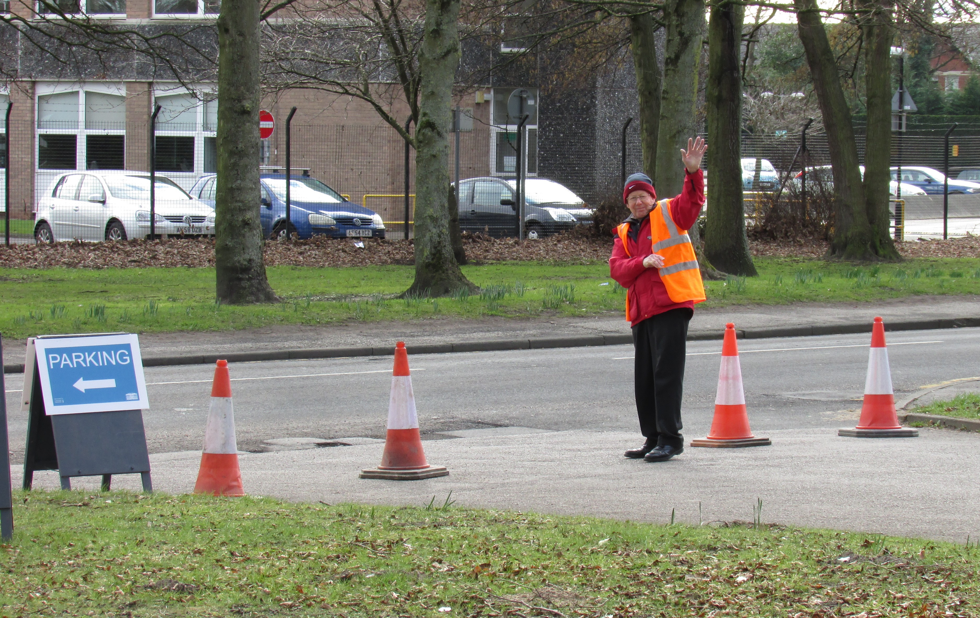
Extra information

Your place Lytham Hall, Ballam Rd, Lytham St Annes FY8 4JX
Time Commitment ½ day on Sundays 9.45am-1pm, or 12.45-3.30pm (on a rota)
Benefits free tea/coffee/biscuits

Volunteer Co-ordinator Sue Lowe

Other people Peter Anthony-Manager Paul Lomax-Deputy
Training Induction training plus other training opportunities

About the Heritage Trust for the North West
Lytham Hall is a fine grade 1 listed 18th century manor house on the Lancashire coast. The Hall is situated in 78 acres of mature parkland, and gardens. It is owned by Lytham Town Trust but managed by the Heritage Trust for the North West (HTNW-Charity Number: 508300) which is a Building Preservation Trust. Its aims are to restore and find appropriate new uses for Buildings at Risk in the North West. As it is a charity we rely on volunteers for day to day help across many areas.



